Final Report

Name: Charles Taggart
Course / Cohort: FSDI 113 / CH 65
Assignment: 113 Final Report
GitHub Repository Link: https://github.com/chucktagg83/112-Django.git

Evidence of Functionality
Frontend/UI
Backend/Logic:
Authentication – Login/Logout, Change Password (Available after authentication)
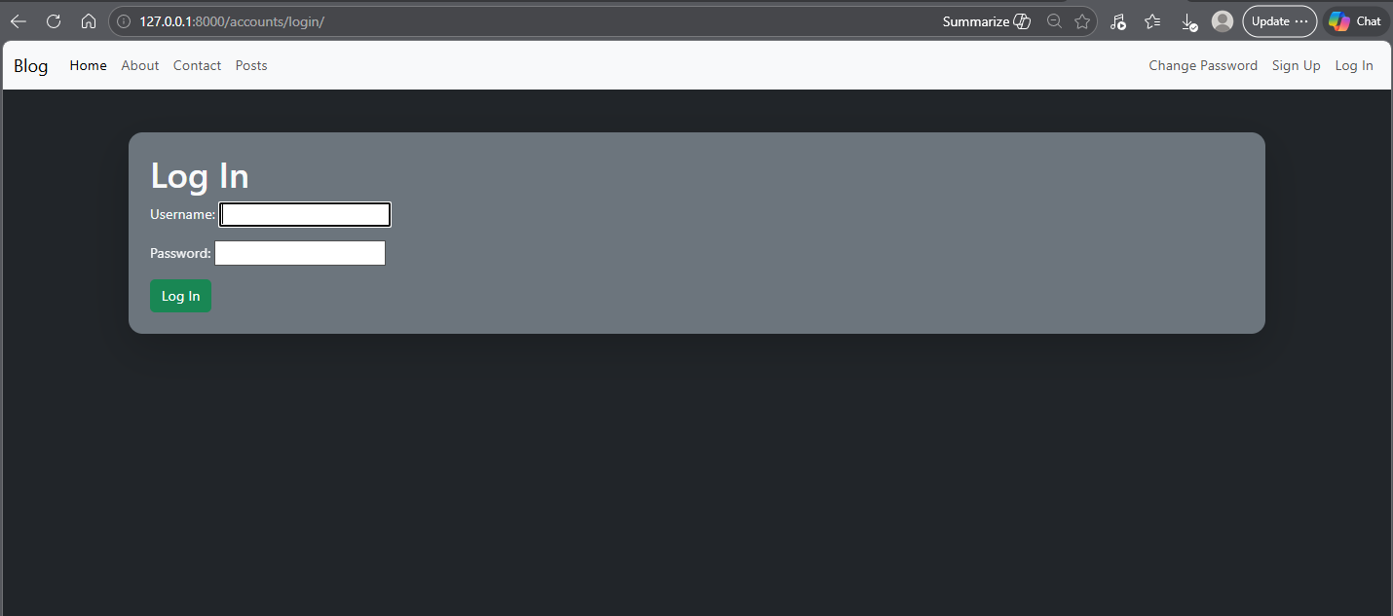

Sign Up Function
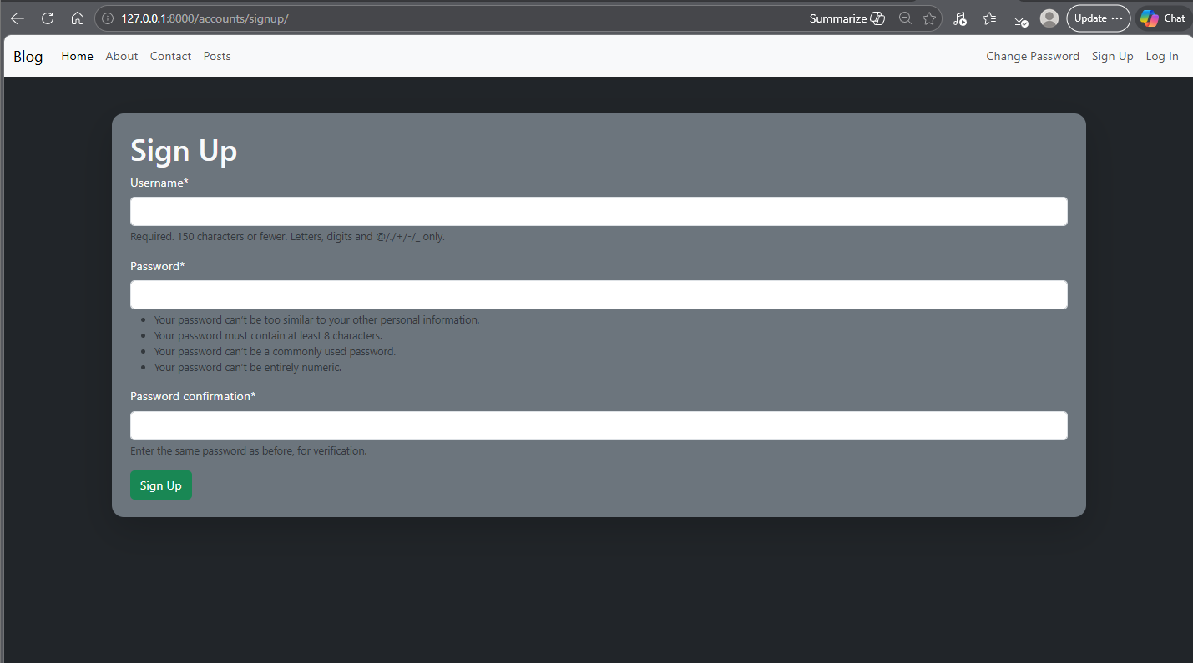

Password Change Flow (After authentication):
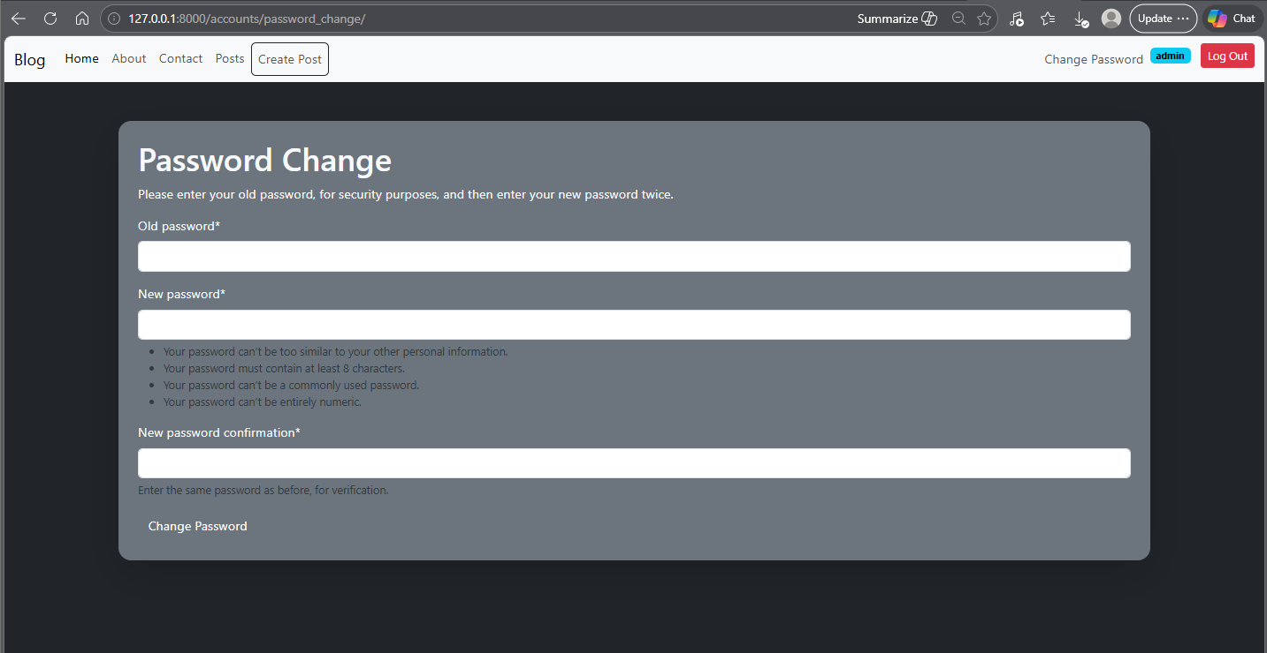

Retrospective
1.Which part of the project was the most difficult or challenging for you, and why?
At this point, I think Django might be the topic that I have enjoyed the most within this course, but there is so much information to try and retain. The hardest part thus far has been trying to keep up and retain any of the information. I’m still trying to get/strengthen my baseline knowledge of Django, but every class we are learning so much more about the capabilities, so I think it will take a while to become proficient, but I do see where this is a one-stop-shop for creating a nice site. I do see how all of the security aspects play a part and what is available, but I have not fully grasped the concepts of making everything work on my own yet (I was able to keep up in class, but definitely not ready to do it on my own, yet).
2. What did you enjoy the most or learn the most from while working on this project, and why? I enjoy that this has a somewhat formulaic approach to putting together a website/app, but there are a lot of steps to remember and attention to detail that has to be paid. I struggle with time to practice outside of the classes with working 12 hour shifts, but I have been trying to make some time to practice with these Django steps to try and get a better grasp on things.

AI Disclosure (Required) – Highlight the one that applies
- I did not use AI
- I used AI for help
- AI generated parts of my code (if it’s the case, provide an explanation of the code in your own words).

